# **Computer Programming Lab 3**

**Nabeel Ali BEE173059 Section-3**

## Activity 1:

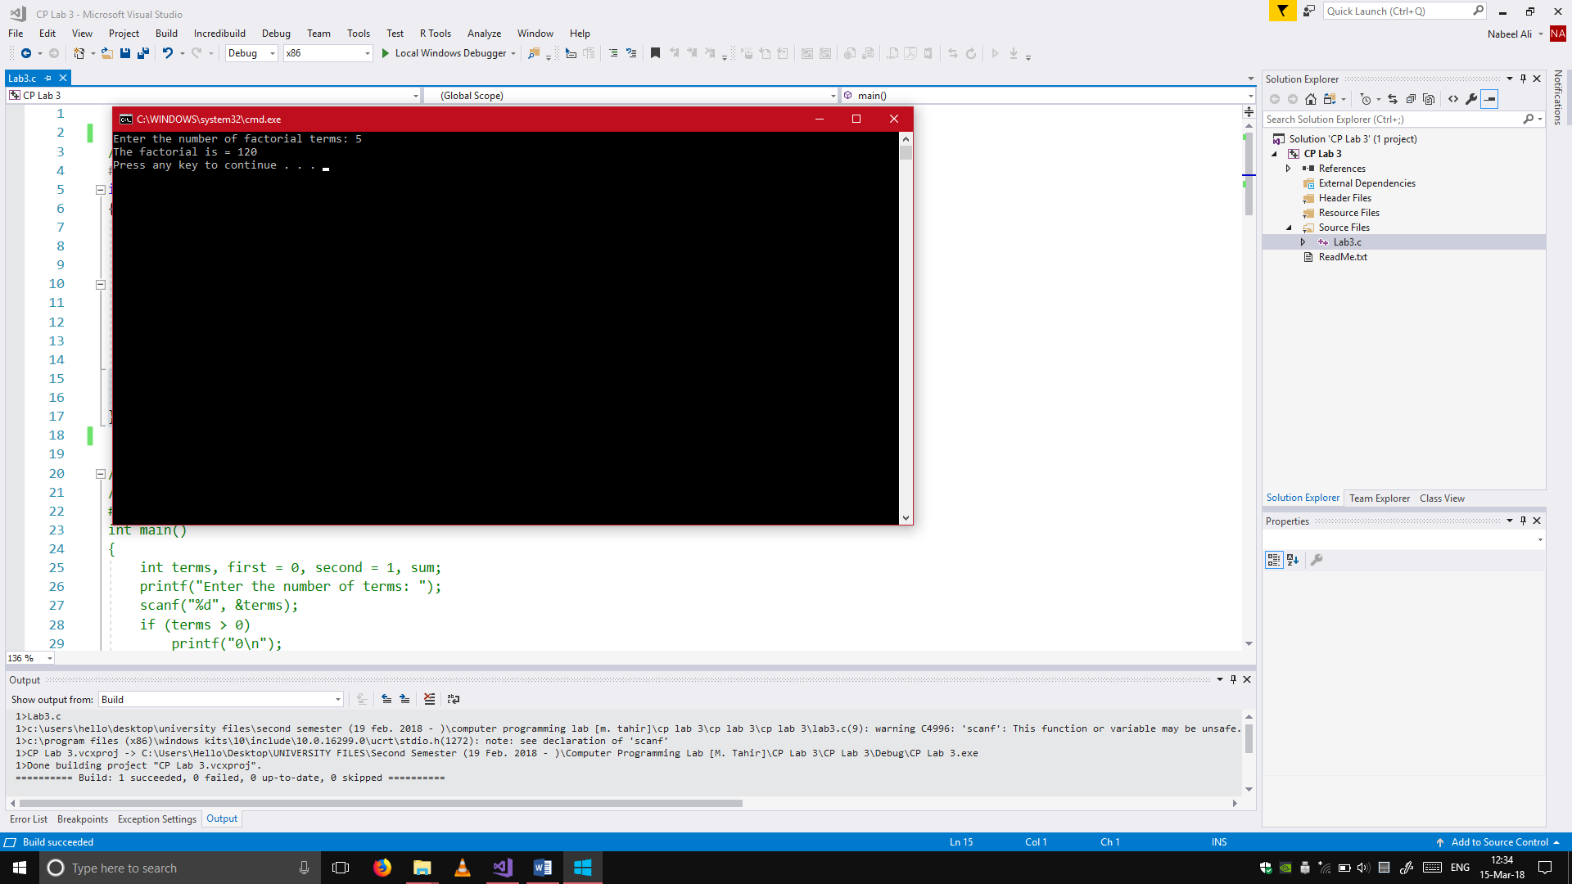//Activity 1

#include <stdio.h>

int main()

{

int i = 1, terms, factorial = 1;

printf("Enter the number of factorial terms: ");

scanf("%d", &terms);

while (i <= terms)

{

factorial = factorial * i;

i++;

}

printf("The factorial is = %d\n", factorial);

return 0;

}

## Activity 2:

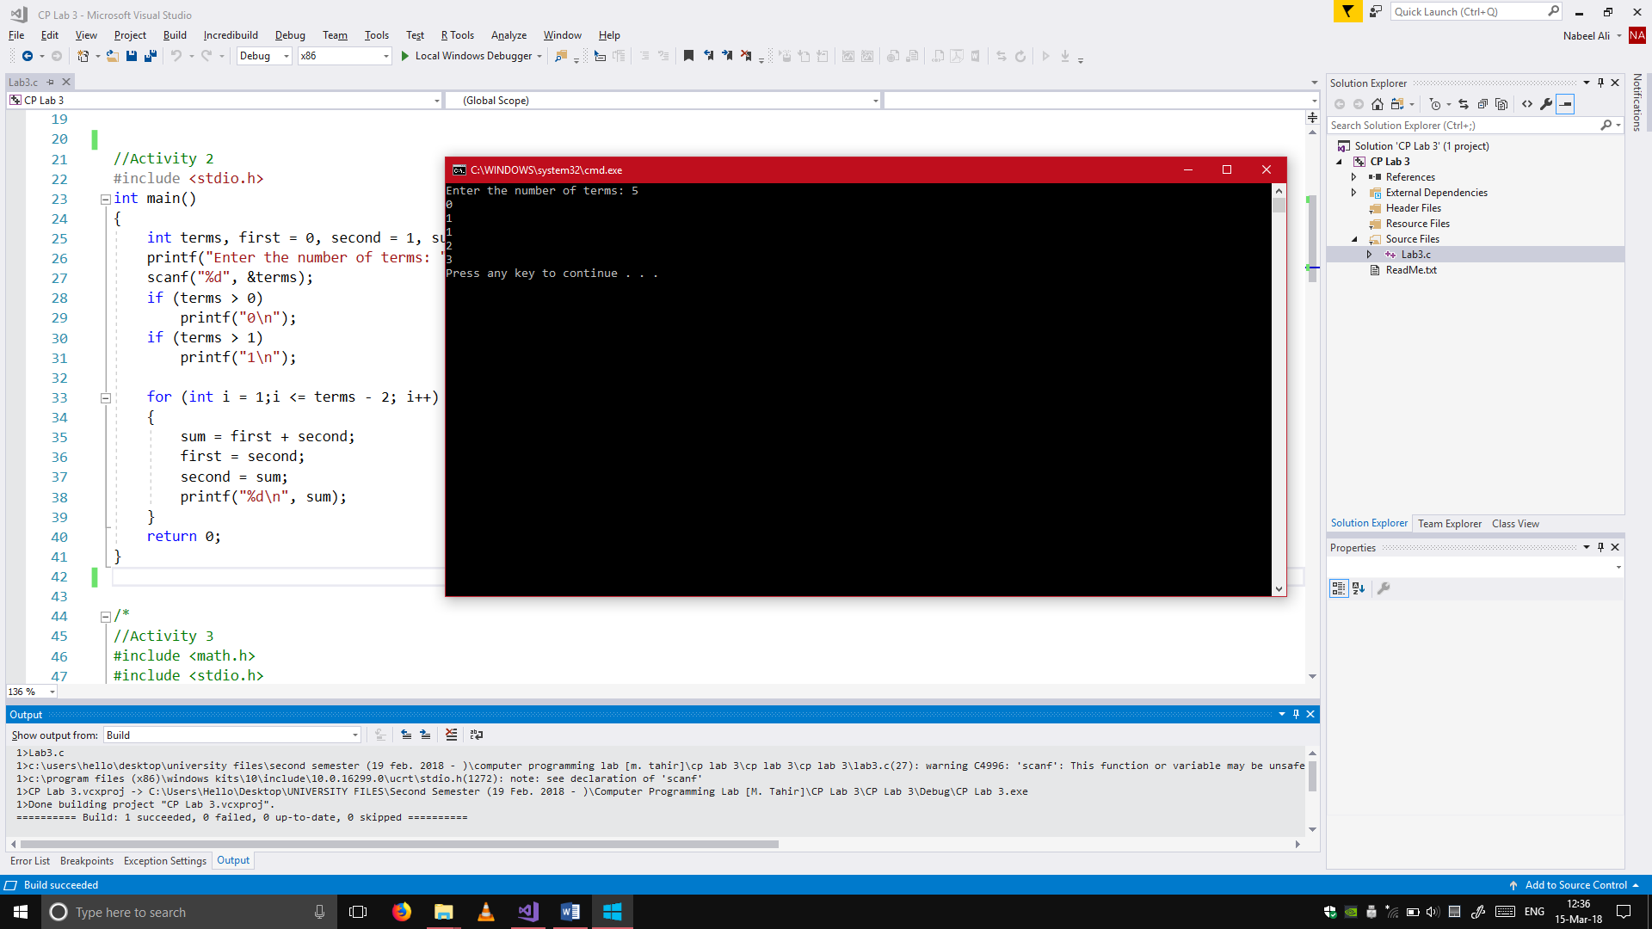//Activity 2

#include <stdio.h>

int main()

{

int terms, first = 0, second = 1, sum;

printf("Enter the number of terms: ");

scanf("%d", &terms);

if (terms > 0)

printf("0\n");

if (terms > 1)

printf("1\n");

for (int i = 1;i <= terms - 2; i++)

{

sum = first + second;

first = second;

second = sum;

printf("%d\n", sum);

}

return 0;

}

## Activity 3:

//Activity 3

#include <math.h>

#include <stdio.h>

void main()

{

int i = 0;

do

{

float perp, base, hyp, P, B, H;

char retry;

printf("Enter the perpendicular: ");

scanf("%f", &perp);

printf("Enter the base: ");

scanf("%f", &base);

P = pow(perp, 2);

B = pow(base, 2);

hyp = P + B;

H = sqrt(hyp);

printf("%f\n", H);

printf("Press 'E' to exit.\nPress any other key to continue.\n");

scanf(" %c", &retry);

if (retry == 'E' || retry == 'e')

{

i = 1;

}

printf("\n");

} while (i == 0);

}

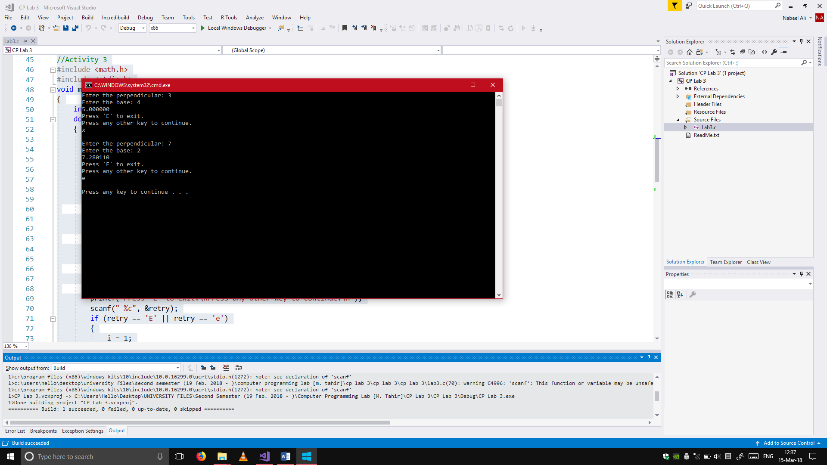

## Activity 4:

//Activity 4

#include <stdio.h>

void main()

{

for (int line = 1;line <= 6;line++)

{

for (int space = 1;space < line;space++)

{

printf(" ");

}

for (int asterisks = 6;asterisks >= line; asterisks--)

{

printf("*");

}

printf("\n");

}

}

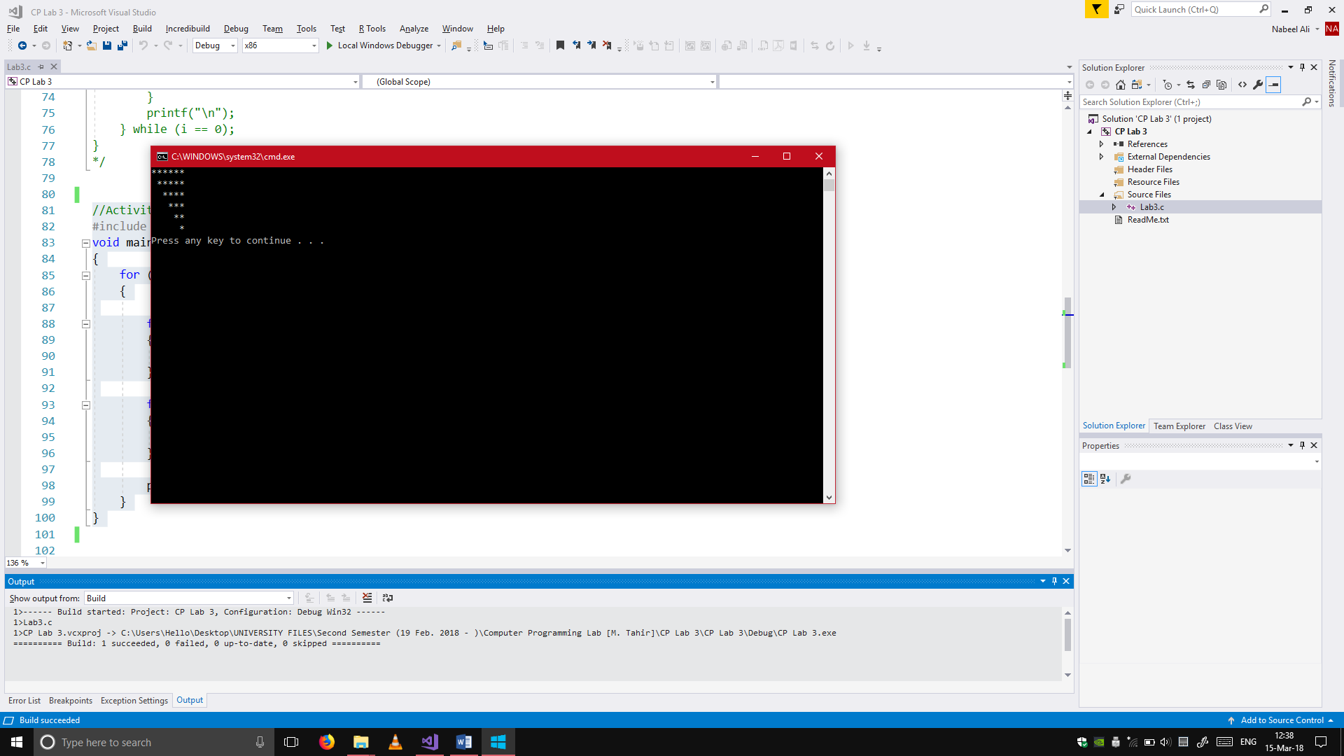

## Bonus Activity:

#include <stdio.h>

void main()

{

for (int line = 1;line <= 5;line++)

{

for (int space = 4;space >= line;space--)

{

printf(" ");

}

for (float asterisks = 1;asterisks <= 2 * line -1;asterisks++)

{

printf("* ");

}

printf("\n");

}

}

